## The Train Tracks

The Train Tracks tool allows you to quickly add train or tram (light rail) lines to your plan.

**To place a train line:**

* Select the **Train Tracks** tool from the Infrastructure tab in the Tools Palette
* Click once to start your rail line.
* Click at each turn point.
* Right click to stop drawing.
* 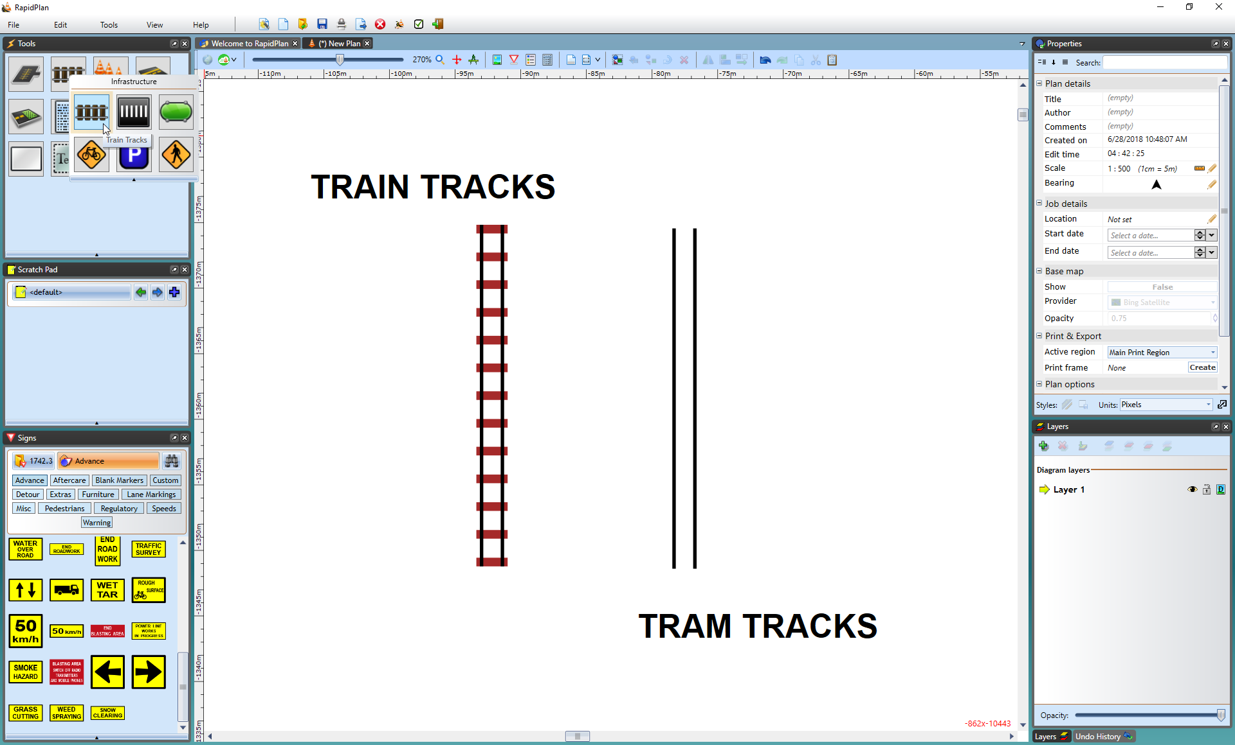
* Train_Tracks_and_Tram_Tracks

To place a tram line on **Properties palette** change **Type** value from **Train** to **Tram**

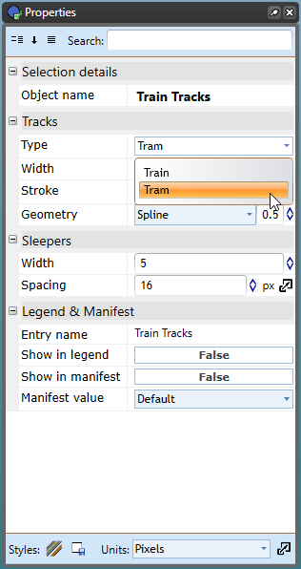

Train_Tracks_tool_types